# Apply filters to SQL queries

## Project description

I was able to filter various information from database, to meet required conditions.

## Retrieve after hours failed login attempts

## 

## Retrieve login attempts on specific dates

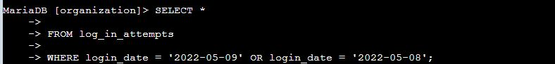

## Retrieve login attempts outside of Mexico

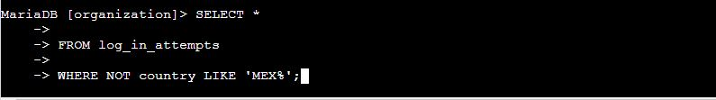

## Retrieve employees in Marketing

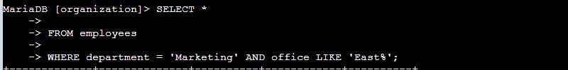

## Retrieve employees in Finance or Sales

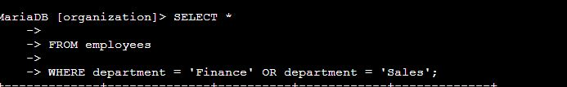

## Retrieve all employees not in IT

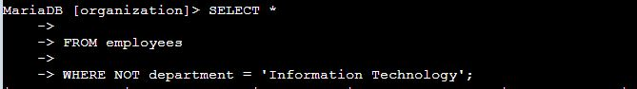

## Summary

I was able to to get information as required, I used SQL as a tool for this project.